

Desert Milkweed – Asclepias subulata
Details: This unique, tall plant grows straight up to the sky and has white clusters of flowers that bloom from the Spring to the Fall. Naturally, this plant grows throughout the southwest United States and Mexico and can be often found in washes out in nature.

THE BASICS
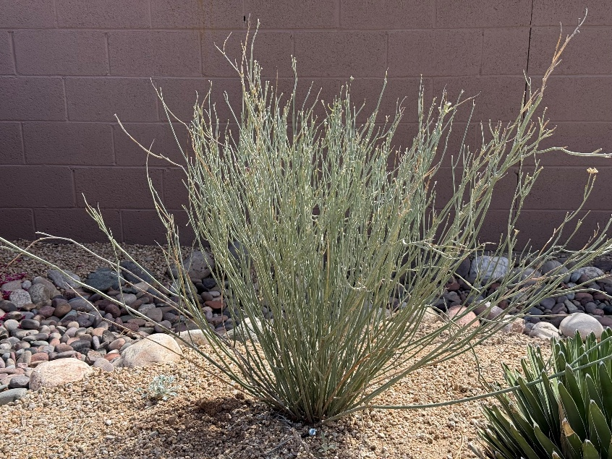
- Type: Evergreen
- Sun: Reflected Sun
- Hardiness: 20°F,
- Water: Very low
- Native to: Mohave
and Sonoran deserts
GROWTH
- Growth Rate: Moderate
- Mature Size: 4’ ft (H) x 4’ ft (W)
WILDLIFE
- Hummingbirds
- Butterflies
- Bees
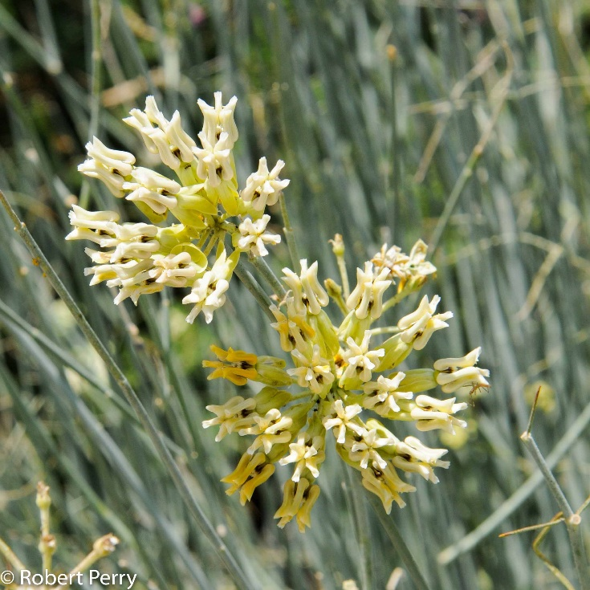
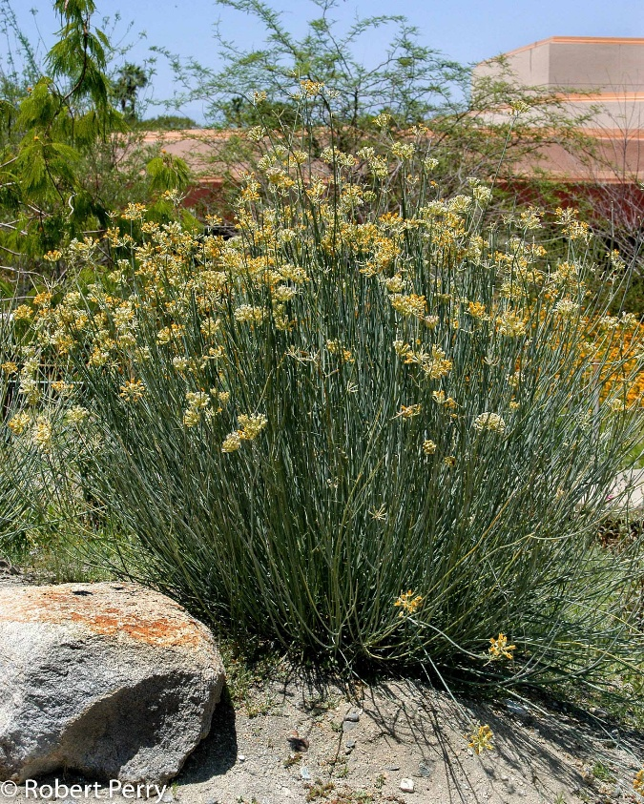

Desert Marigold – Baileya multiradiata
Details: This flowering waterwise species is adapted to arid landscapes and provides a bright gold flower that blooms in spring and can last until fall.
Fun fact: Desert Marigold used to be used to treat various ailments such as skin irritations, wounds, and digestives issues, as the plant contains compounds with anti-inflammatory and antiseptic properties.
THE BASICS
- Type: Perennial
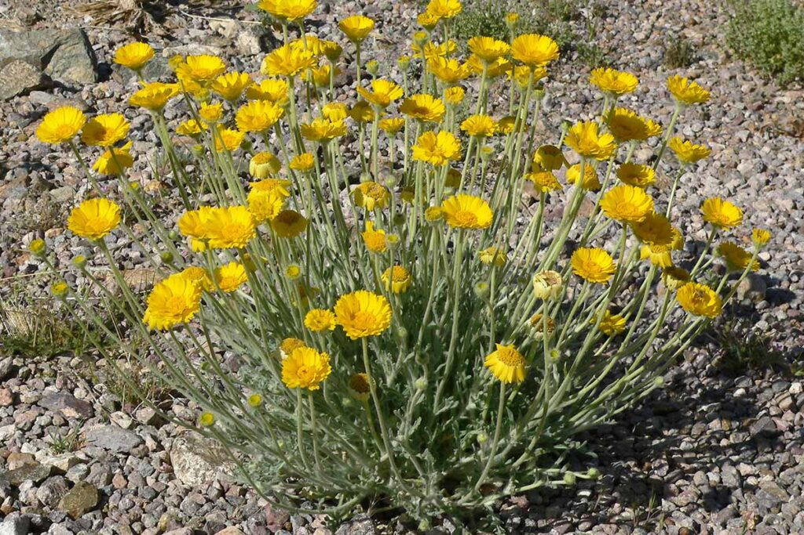
- Sun: Full sun
- Hardiness: 10°F
- Water: Little to Moderate
- Native to: The Southwest and the Chihuahuan Desert
GROWTH
- Growth Rate: Moderate
- Mature Size: 1-2 ft (H) x 2 ft (W)
- Mature Form: Sprawling
WILDLIFE
- Butterflies
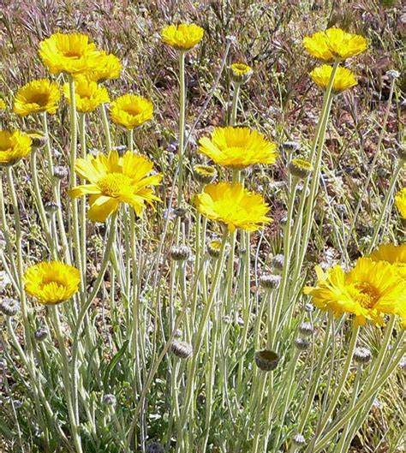
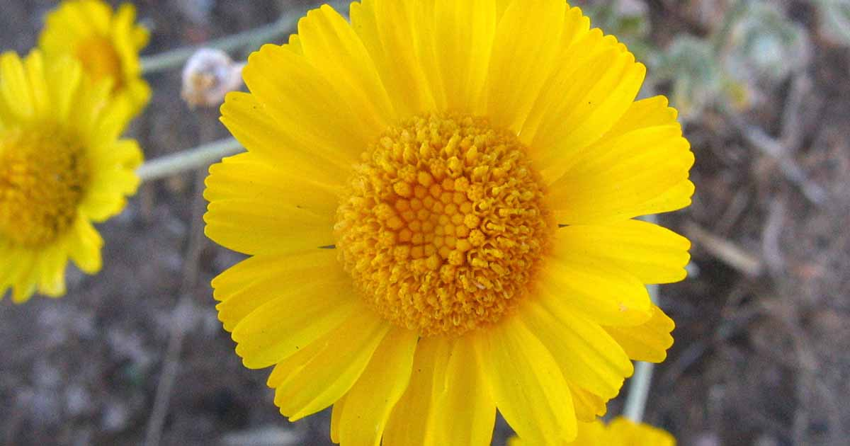
- Pollinators
Velvet Mesquite, Prosopsis velutina
Details: Velvet mesquite has white, greenish yellow to pale yellow flowers that flowers from April to June.
Fun fact: The velvet mesquite is one of the most drought tolerant trees, withstanding the sun’s heat and light. This is a good option for next to a south or west wall.
Tip: In the wild, many desert animals have been documented to feed off of the mesquite pods (javelina, wild turkeys, quail, rodents, cottontails, and porcupines).
THE BASICS
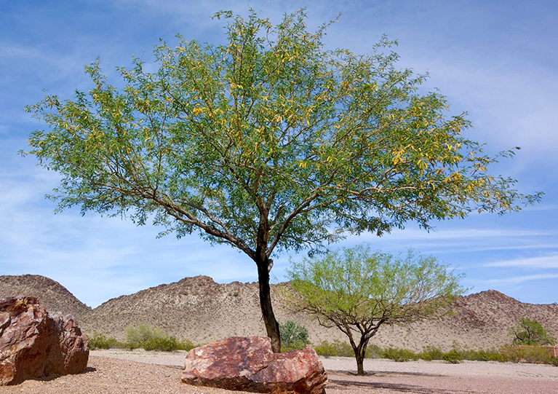
- Type: Deciduous tree
- Sun: Full/ reflected sun
- Water: Very low
- Native to: Chihuahuan and Sonoran deserts
GROWTH
- Growth Rate: Moderate to fast
- Mature Size: 25’ tall, 25’ wide
- Mature Form: Wide crown
WILDLIFE
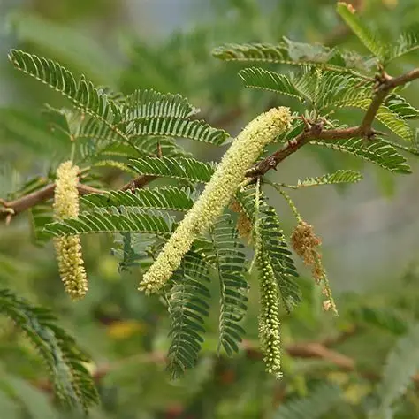
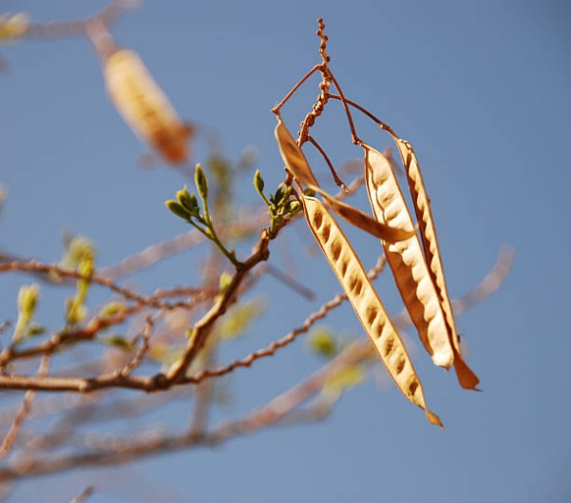
- Bees
- Butterflies
- Hummingbirds

Golden Barrel – Echinocactus grusonii
Details: This spherical green cactus with yellow flowers in the Spring is a striking accent to any desert landscape.
Fun fact: Over time, this cactus can take on a more oblong shape and tends to lean to the south or the southwest so that the spines of the cactus can better protect the body of the plant from the desert sun.
THE BASICS
- Type: Evergreen
- Sun: Full, partial sun
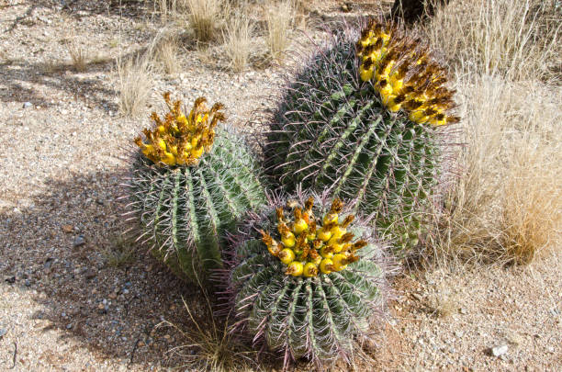
- Hardiness: 18°
- Water: Low
- Native to: Central and
southern Mexico
GROWTH
- Growth Rate: Slow
- Mature Size: 2‘(H) x 2’(W)
- Mature Form: Globe shaped
WILDLIFE
- Bees
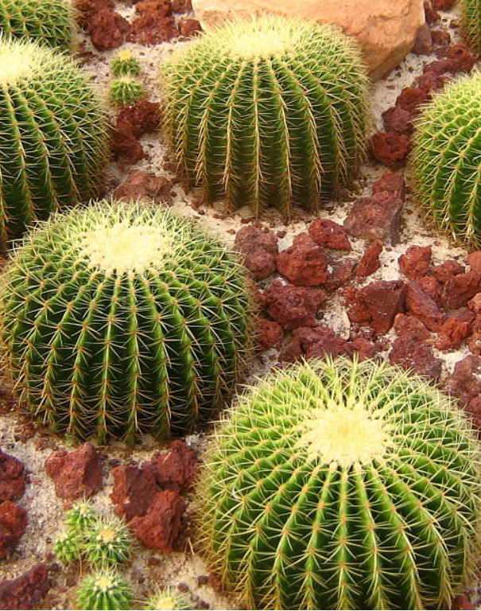
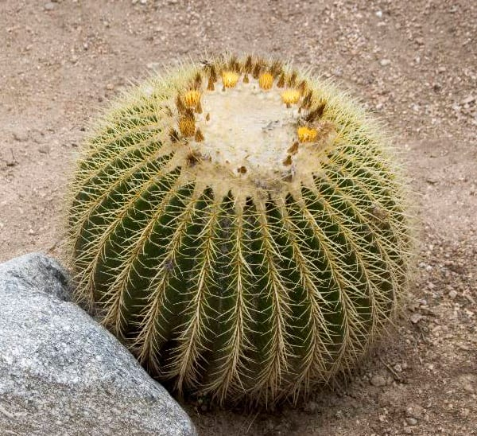
- Butterflies

Brittlebush – Encelia farinosa
Details: Brittlebush is a tolerant, fast-growing shrub that can be seen blooming all across the valley.
Fun fact: The silvery look of a brittlebush plant is due to small, hairlike structures on the plant that act like a blanket on the leaves to protect them from the heat and the cold, and reduce the amount of water that the plant loses.
Tip: Brittlebush produces seeds that are dispersed by the wind and tend to sprout after heavy rains (like this past fall/ winter). If you do not want this plant to pop up elsewhere in your landscape, this may not be the best plant for you!
THE BASICS
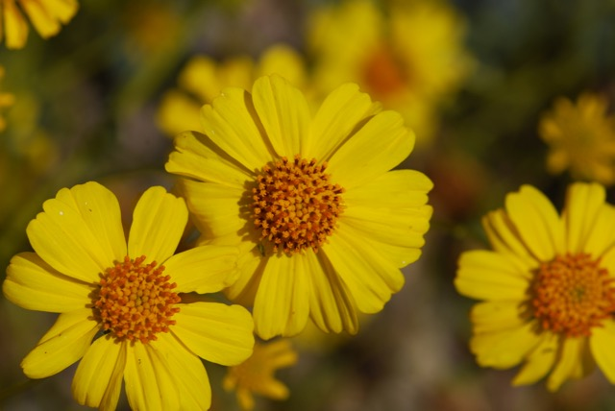
- Type: Evergreen shrub
- Sun: Reflected sun
- Hardiness: 25°
- Water: Very low
- Native to: Sonoran desert
GROWTH
- Growth Rate: Fast
- Mature Size: 3‘(H) x 4’ (W)
- Mature Form: Mounding
WILDLIFE
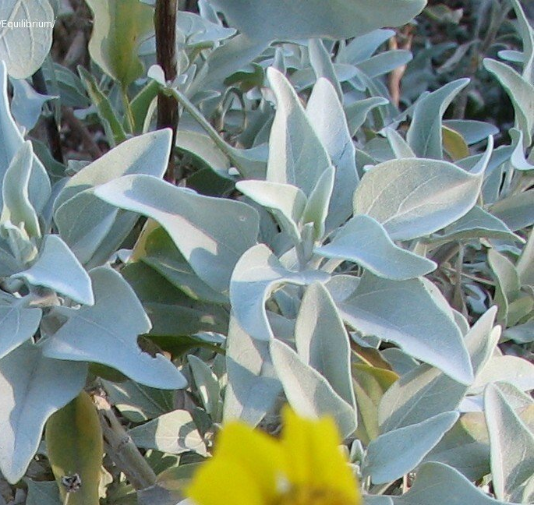
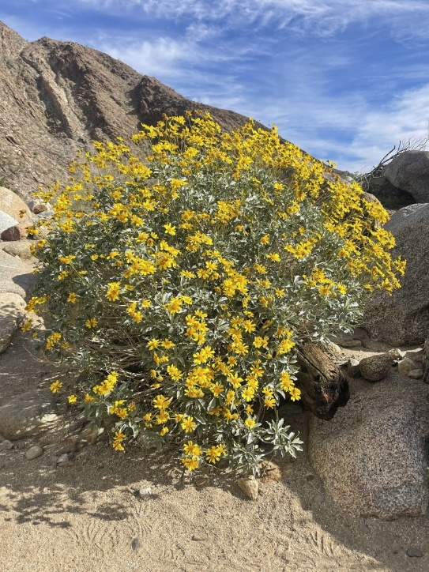
- Bees
- Hummingbirds
- Butterflies

Century Plant - Agave americana
Details: This large, sculptural succulent is well known for its dramatic flower spike that appears later in the plant’s life.
Fun fact: The Century Plant got its name due to the belief that this plant flowers once a century. In reality, this plant typically only lives 10-30 years.
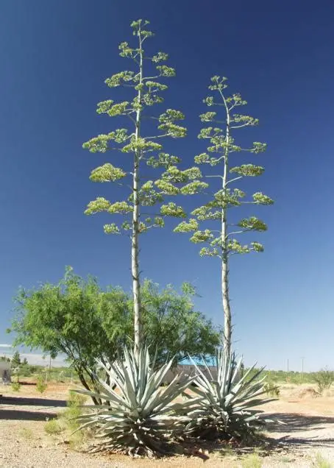
THE BASICS
- Type: Perennial succulent
- Sun: Full sun
- Hardiness: 20°
- Water: Very low
- Native to: Mexico and the southwestern US
GROWTH
- Growth Rate: Slow
- Mature Size: 3-6’ (H) x 6-10’ (W)
- Mature Form: Upright
WILDLIFE (attracts when in bloom)
- Bees
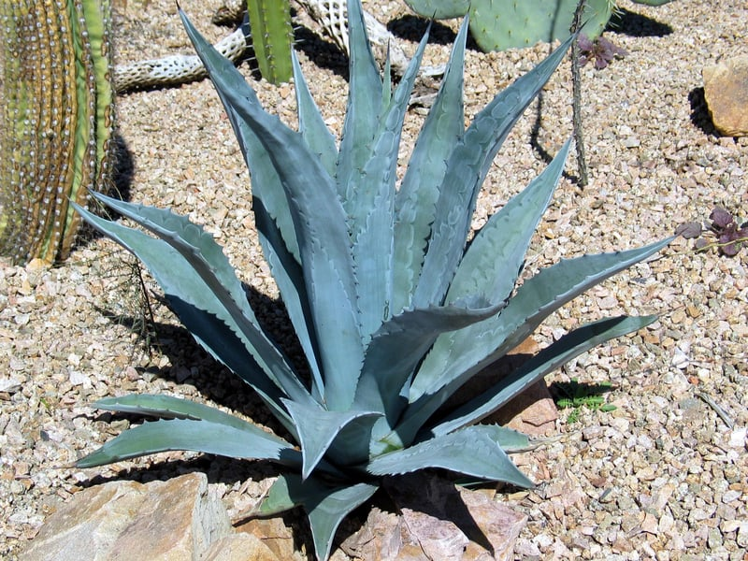
- Butterflies
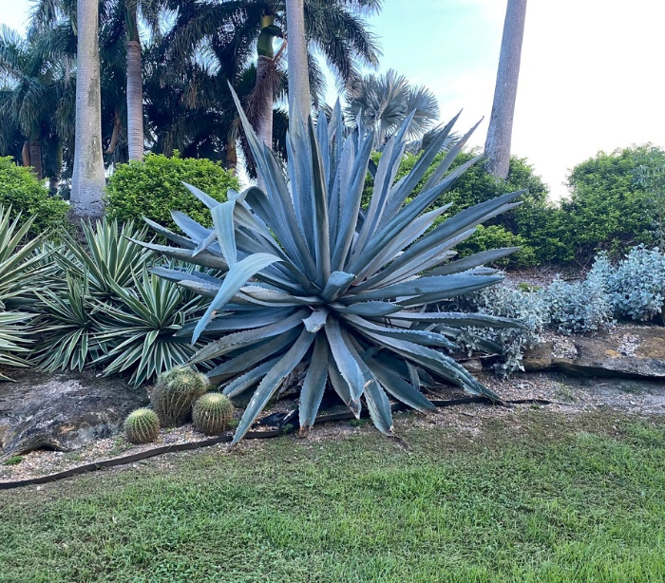

Orange Jubilee, Tecoma orange
Details: This plant features bright orange, trumpetlike clusters in spring and fall.
Fun fact: Tecoma orange have been used in herbal medicine to treat digestive issues to skin conditions.
THE BASICS
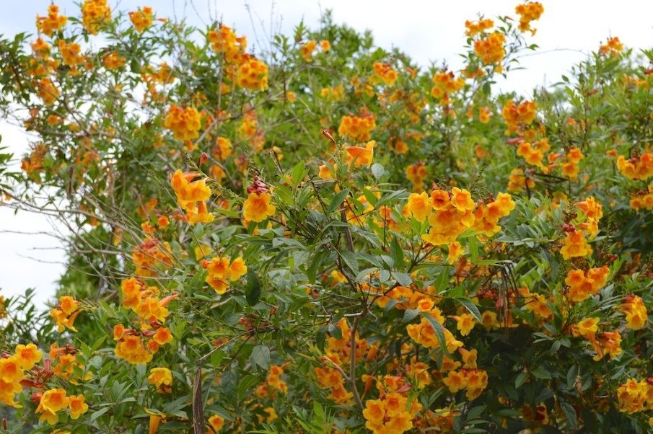
- Type: Semi-evergreen
- Sun: Full sun
- Hardiness: 28°F
- Water: Moderate
GROWTH
- Growth Rate: Fast
- Mature Size: 8 ft (H) x 5 ft (W)
- Mature Form: Upright
WILDLIFE
- Hummingbirds
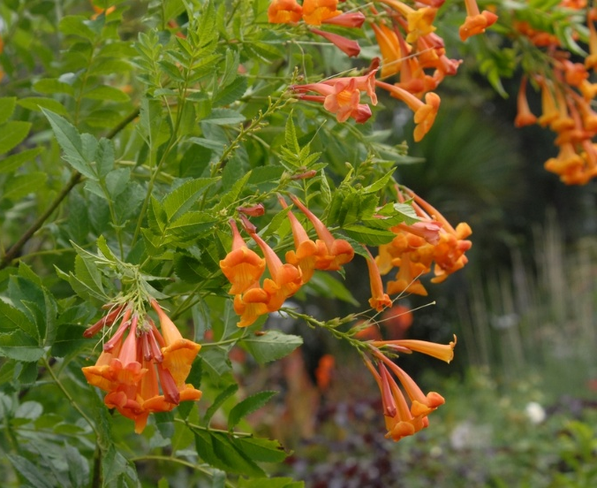
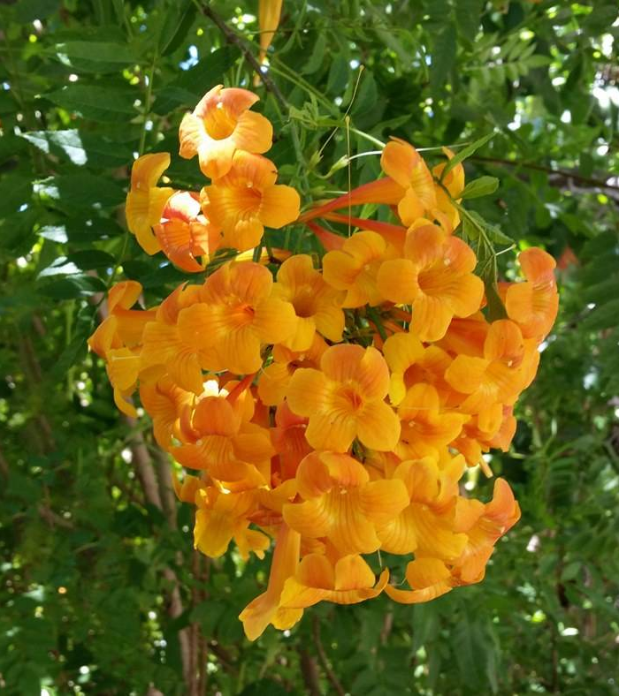

Royal Fog - Muhlenbergia capillaris
Details: Also known as pink muhly, this grass is a thorn free, litterless option that flowers in the fall.
Tip: Put the pink muhly grass where the pink flower plumes can be backlit by the sun!

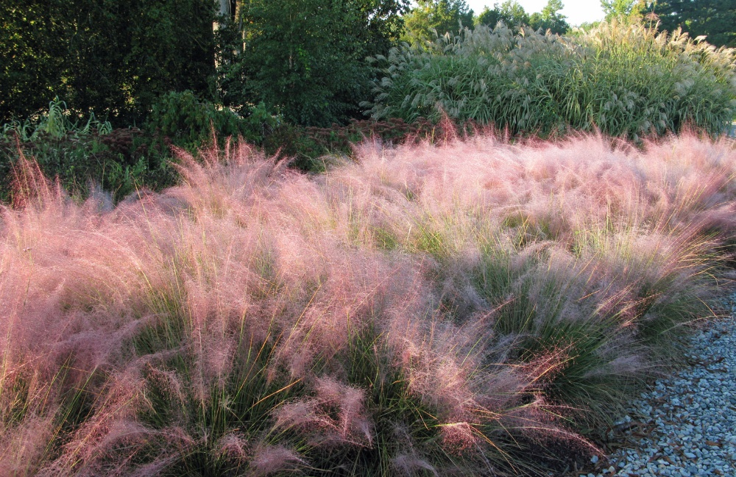
THE BASICS
- Type: Grass
- Sun: Full sun/ partial sun
- Hardiness: 0°
- Water: Low
- Native to: Texas and
southeastern US
GROWTH
- Growth Rate: Fast
- Mature Size: 3’ (H) x 3’ (W)
- Mature Form: Mounding
